Student ANGEL FAQ
ANGEL URL: angel.gannon.edu (log-in information is Gannon user id and password)

Question 1:
How do I login into the ANGEL system and enter into a course? ANSWER

Question 2:
How do I check my grades? ANSWER

Question 3:
How do I add an assignment to a Drop Box? ANSWER

Question 4:
What is ANGEL Course Mail and how do I use it? ANSWER

Question 5:
What are Discussion Forums and how do they work? ANSWER

Question 1:
How do I login into the ANGEL system?

Answer:
Login
Point your browser to http://angel.gannon.edu.  The ANGEL login page displays Public Information, a Search & Help section and General Public Announcements.  You will use your standard GannonID (e-mail, UPortal) to login to ANGEL. | 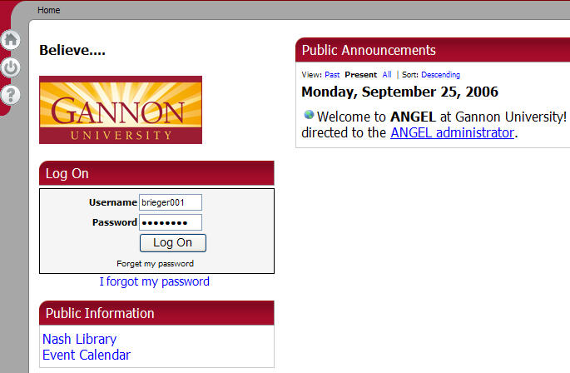
Once logged in, you will see the Systems Navigation tool bar. These buttons will allow you to access different areas of ANGEL. |   Log Off  Learning Object Repository  Instant Messenger (currently disabled)  Home  Help  Preferences
Access the ANGEL course you would like to work with by clicking on the course title within the Courses Nugget. | 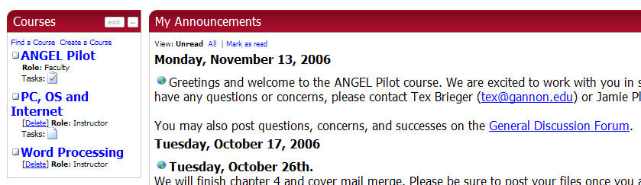

Question 2:
How do I check my grades?

Answer:
If your instructor is entering grades into ANGEL, you are able to access your grades under the Report Tab. Once at the Report Tab, there are many options for seeing your progress in the course (providing that your instructor is entering the data into ANGEL.)

Report Tab Course Progress Options  Lerner Profile: Graphically shows your course progress. Click on Data option in the left column to view specific items.  Grades: Lists the course assignments and your grades by category  Milestones: Lists the course milestones, when it was assigned, when it was due and if the milestone has been completed. *Not all instructors will use Milestones.  NOTE: Shown here are the Gradebook Grades as seen in the Learner Profile View. | 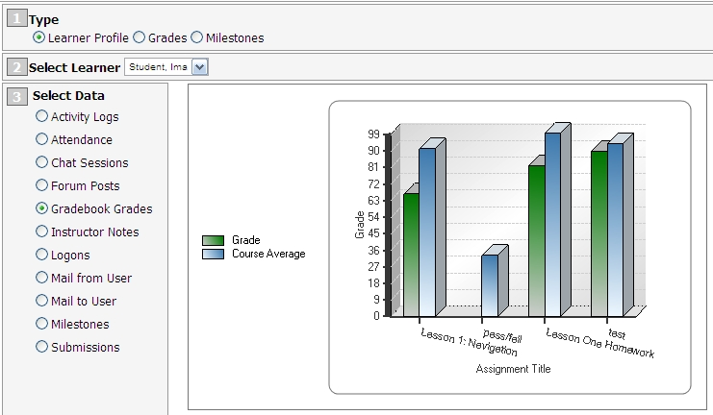

Question 3:
How do I add an assignment to a Drop Box?

Answer
There are two ways to add an assignment to a Drop Box. Be sure to follow your instructor’s directions.
Upload a file to the Drop Box  - Identify the appropriate Drop Box and click on the Drop Box title.  - Enter in the title of your assignment  - Click on the Attachments button at bottom of screen  - Browse for your file  - Click on the Upload File button  - Be sure you see your file in the “Uploaded Files” box  - Click Finished when all files have been added. | 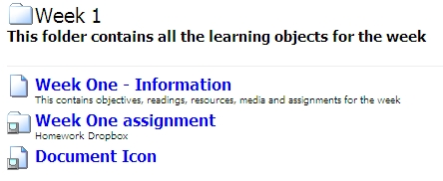
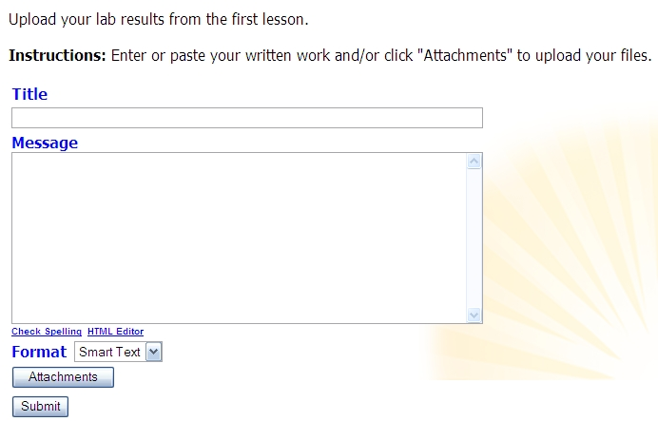
Enter title here
 | 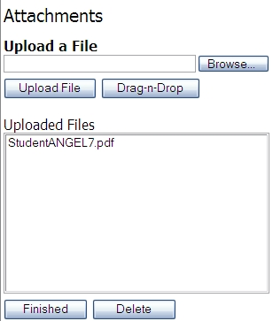
Enter or paste your written work  - Enter in the title of your assignment  - Enter assignment text or paste assignment text into Message Field  - To access the HTML Editor, click on the HTML Editor link under the Message Field. This will give you a Microsoft Word-like screen.  - Click Submit  NOTE: If you use the HTML Editor, be sure you click the Accept Changes button at the bottom of the editor. | Enter title here  Enter text here  HTML Editor

Question 4:
What is ANGEL Course Mail and how do I use it?

Answer
ANGEL Course Mail is a mail tool that allows you to send message to your colleagues and instructors in your course. By default, all messages sent using ANGEL Course Mail will be forwarded to the recipient’s Gannon mail account.

ANGEL Course Mail editor works like most other electronic mail messaging systems. You are able to select recipients, add attachments and use the HTML Editor to edit font, color, add Web links and more.

Please be sure to follow your instructor’s preference for electronic mail.

ANGEL Course Mail  Click on the Communicate Tab  Select the Mail option you wish to review: Send Course Mail, Read Course Mail, Sent Mail Folder | 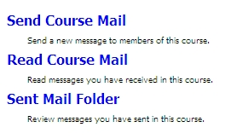
Sending a Message  - Click on Send Course Mail  - Select recipients. To select individual recipients, highlight their name and click the “TO->” button.  - Add Subject  - Compose Message  - Click Send | 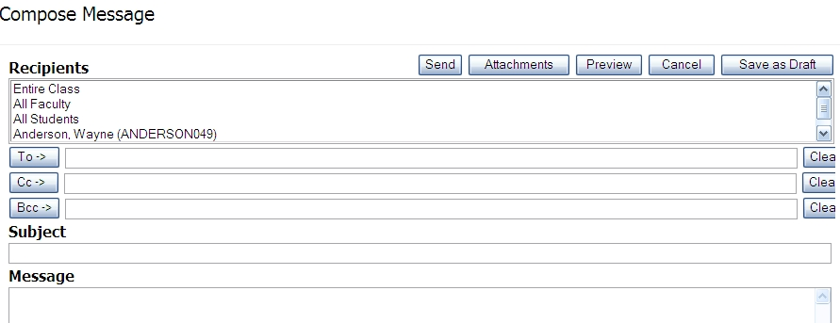
Viewing a Message  - Click on Read Course Mail  - Click on the Sender or the Subject of the message  Filing Messages  - Select the checkbox next to the message(s) you want to move  - Select the folder you want to move the messages to from the Move to Folder list | 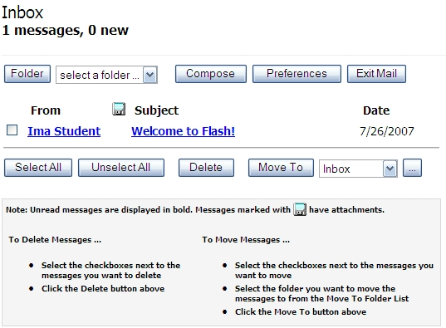
Question 5:
What are Discussion Forums and how do they work?

Answer:
Discussion Forums are a way that you are able to communicate with your colleagues and instructors in a managed format. Discussions are built within “threads” of topics and you are able to reply or “post” to these threads.

When communicating in a Discussion Forum, be sure to use proper netiquette. All caps imply that you are yelling; misspellings and poor grammar are noticeable. Remember, when you post a reply or start a thread, it is there for the whole class to see.

Discussion Forums
You can access Discussion Forums via the Lessons Tab or Communicate Tab.  From the Lessons Tab, you will have to enter into the folder where the Discussion Forum has been created.  From the Communicate Tab, the Discussion Forums are located in the Discussion Forums Nugget.  - To create a new Thread, click on New Post found in the upper right corner.  - To rely to a post, open the thread by clicking on its title and then click Reply within the new window; located at the bottom right. | 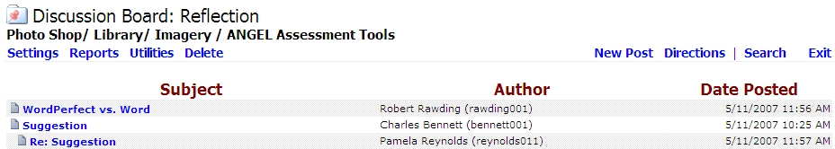  Thread  Reply
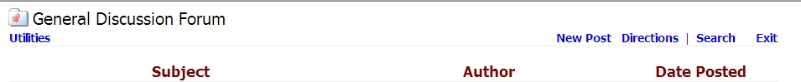
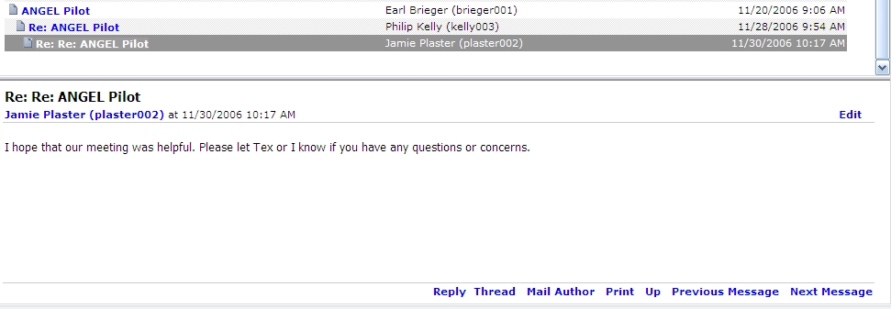
Discussion Area

